**Natural Language Processing with Disaster Tweets**

Bridget D. Harrell

[bhar4180@365.elmhurst.edu](mailto:bhar4180@365.elmhurst.edu)

Department of Computer Science and Information Systems, M.Sc. Data Science

Elmhurst University

Elmhurst, IL

# ABSTRACT

Natural language processing is a set of models used to analyze and process significant amounts of text and spoken words. Social media is full of textual information that may benefit third-party stakeholders. Adequately cleaned and refined, this data becomes valuable. This study takes a beginner’s approach to explore the use of the Naïve-Bayes Classifier to determine if Twitter users are texting about disasters.

***Keywords****:* Twitter, tweet, natural language processing, disaster, emergency

**I. INTRODUCTION**

Founded in 2006 by Kevin Systrom, a Stanford University graduate, Twitter has become one of the top social media sites worldwide. Accounting for 7.44% of the global social media market in February 2022, Twitter is a microblog that allows its users to send out messages with a limit of 280 characters called tweets, including media, links, and text (Statcounter Global Stats). According to Statista, Twitter had 322.4 million active users worldwide in 2021, up from 314.9 million.

Twitter supplies a massive amount of data on which to run models. With approximately 500 million readily available tweets tweeted daily, Twitter is considered a “gold mine of data.” Twitter’s data is also exceptionally detailed.

Because of their need for real-time disaster data, more emergency response agencies and media outlets are interested in using an automated method to monitor Twitter’s tweets. With so many Twitter users tweeting about everyday events, users are likely to tweet about disasters as they occur. Quickly combing through millions of tweets in search of ones concerning actual calamities will be a daunting task.

Natural language processing (NLP), which has existed for decades, is an extension of artificial intelligence and is quintessential to having computers understand human language, in this case, tweets. NLP must be used for a computer to capture each tweet's meaning adequately. While other approaches have been taken to find a model that best helps differentiate between tweets that pertain to real disasters and tweets that do not, this study will compare two approaches by using the Natural Language Toolkit (NLTK) to work with NLP in Python.

**II. DATA**

The dataset for this study was collected from a Kaggle competition supplied by the company figure-eight. The competition is for data scientists new to NLP and does not count toward Kaggle ranking points. This study was for academic purposes only and will not be submitted to Kaggle.

Kaggle supplied both training and testing datasets. Seven thousand six hundred thirteen unstructured tweets (text/ texts) were collected and given an identification number (id) for this study. Words that might signal a disaster (keywords) were extracted from the tweets. Where given by the Twitter user, a location (location) was listed. Observances were labeled with a one if they refer to a disaster or a zero if they do not (target).

**Exploratory Data Analysis -**

By using descriptive statistics and visualization, an Exploratory Data Analysis was performed to help better understand the properties of the training dataset, which are presented in the graph and chart below. Of the 7,613 tweets, 3,271 (42.966%) mention disaster keywords and 4,342 (57.034%) do not (Figure 3).

train.shape, test.shape, test.shape[0]/train.shape[0]

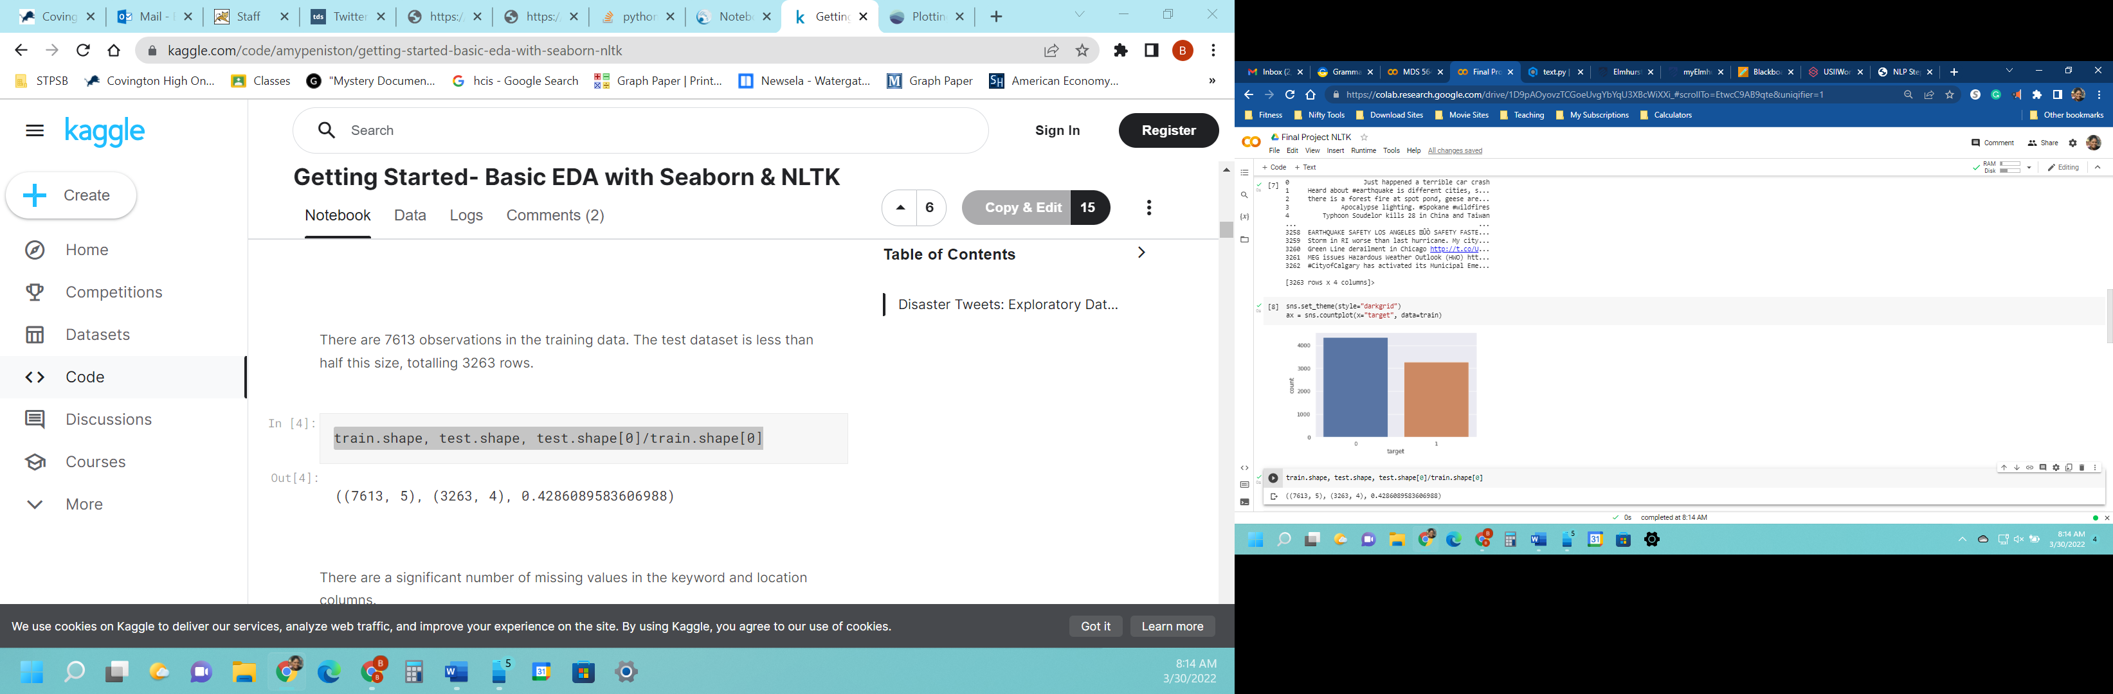

|  |
| --- |
|   *Figure 1. Null variables* |
|   *Figure 5. Top 20 Locations*  sns.barplot(y=train['location'].value_counts()[:20].index,x=train['location']  .value_counts()[:20],orient='h') |
|   *Figure 6. Target*  sns.set_theme(style="darkgrid")ax = sns.countplot(x="target", data=train) |

**Methodology - Natural Language Toolkit (NLTK)**

Before using NLTK, pandas was imported for data analysis, matplotlib for data visualization, and seaborn for “high-level” statistical graphics.

import pandas as pd

import matplotlib.pyplot as plt

import seaborn as sns

Textblob was imported to process textual data, Regular Expression to find a pattern amongst tweets using a particular syntax, stopwords to find words that do not add meaning to the tweets, WordNetLemmatizer to convert words to their base form. From sklearn a CountVectorizer and TfidTransformer were imported to create a matrix with document and token counts and to calculate the Inverse Document Frequency (IDF).

from textblob import TextBlob

import re

from nltk.corpus import stopwords

from nltk.stem.wordnet import WordNetLemmatizer

from sklearn.feature_extraction.text import CountVectorizer, TfidfTransformer

MultinomialNB was imported for classification, train_test_split to split the training and testing data, and pipeline to streamline the order of each step. A confusion matrix, classification report, and accuracy score were imported for output.

from sklearn.naive_bayes import MultinomialNB

from sklearn.model_selection import train_test_split

from sklearn.pipeline import Pipeline

from sklearn.metrics import confusion_matrix, classification_report,accuracy_score

The data files provided by Kaggle were then uploaded to Google Colab and reviewed for accuracy.

from google.colab import files

uploaded = files.upload()

import io

train = pd.read_csv('train.csv')

test = pd.read_csv('test.csv')

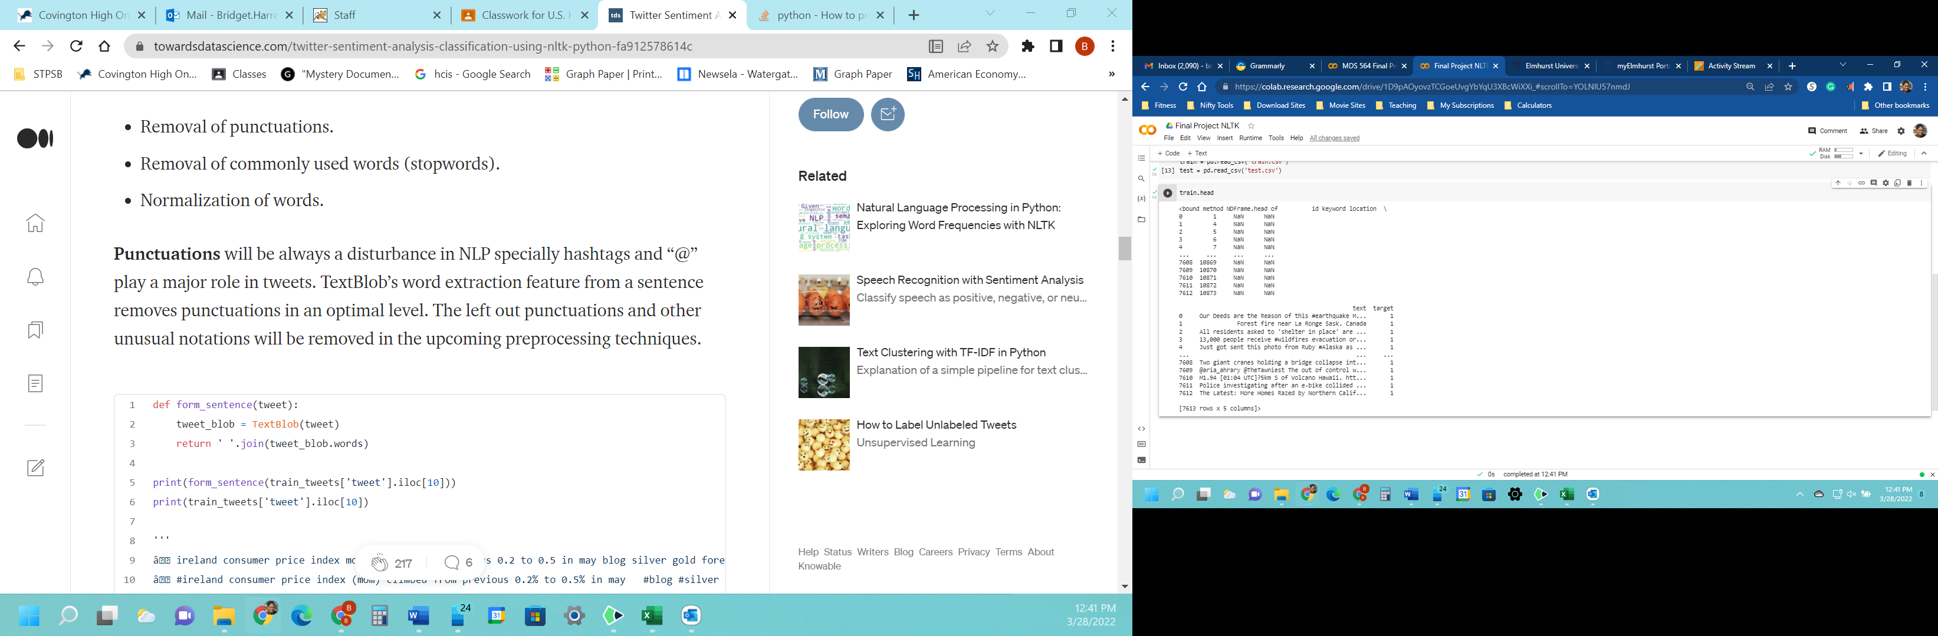

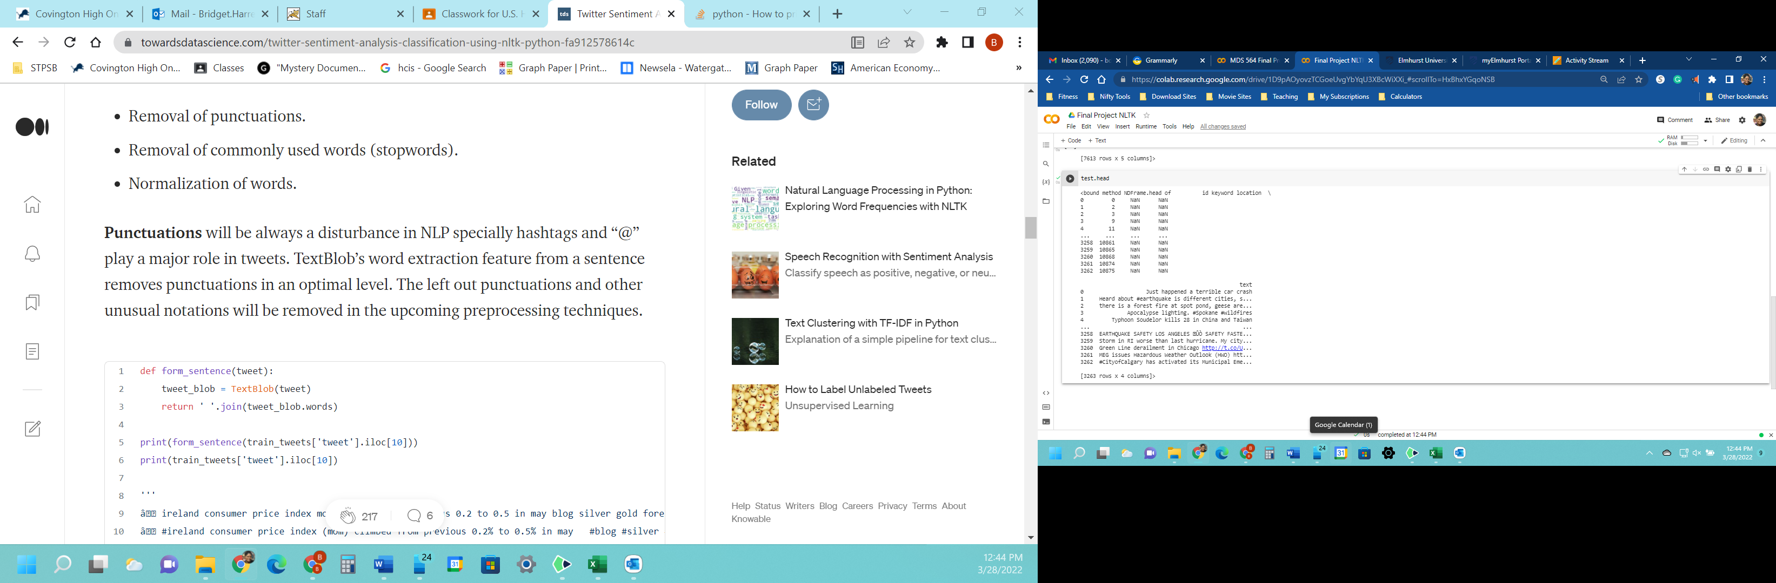

The csv files were read into the pandas data frame.

train_df = pd.read_csv('train.csv')

test_df = pd.read_csv('test.csv')

**Data Preprocessing and Feature Engineering**

Each tweet (texts) needed to be cleaned. Regular Expression was used to remove links, line breaks, and extra spaces.

import re

test_str = train.loc[417, 'texts']

def clean_text(text):

    text = re.sub(r'https?://\S+', '', text)

    text = re.sub(r'\n',' ', text)

    text = re.sub('\s+', ' ', text).strip()

    return text

print("Original text: " + test_str)

print("Cleaned text: " + clean_text(test_str))

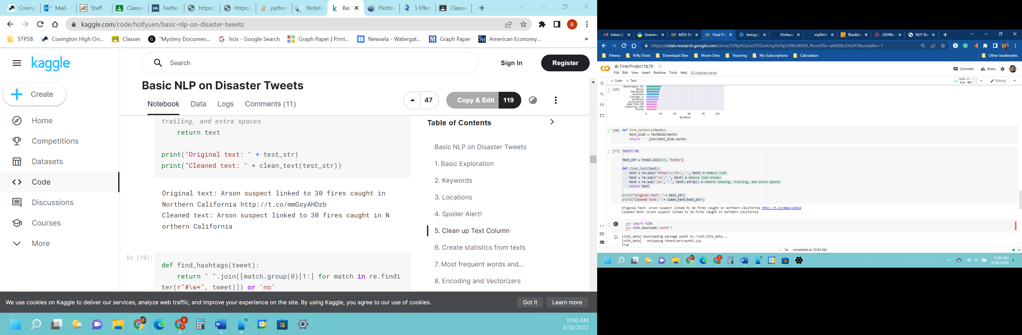

Punctuations had little to no vital part in the tweets. TextBlob was used to remove punctuations from the tweets.

def form_sentence(texts):

    text_blob = TextBlob(texts)

    return ' '.join(text_blob.words)

import string

string.punctuation

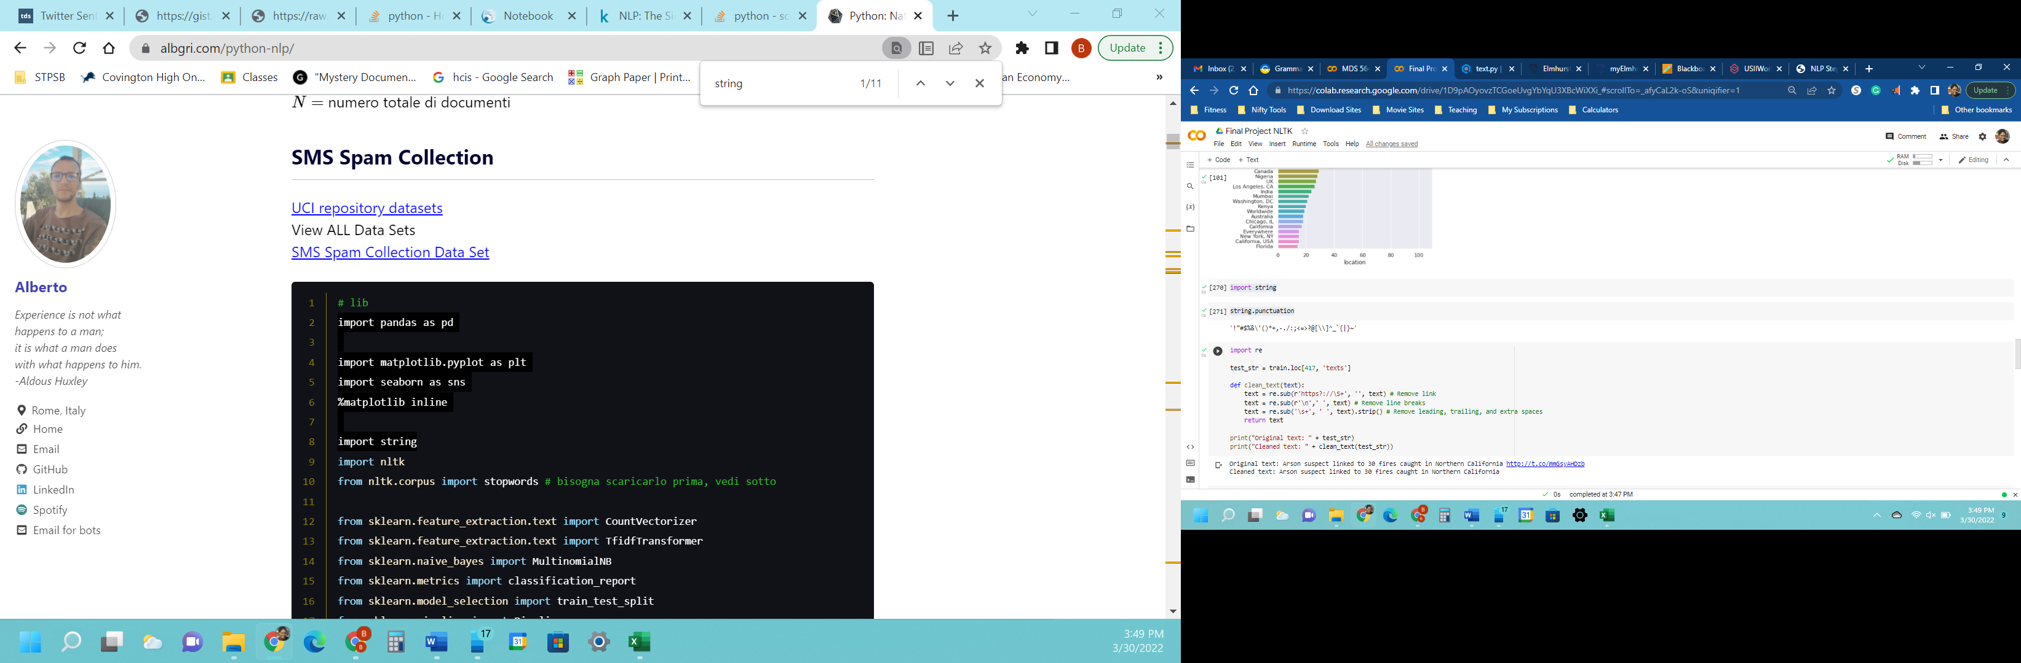

Upon running the code presented above, an error was encountered. Google Colab advised that the Punkt Sentence Tokenizer had to be downloaded.

 import nltk

 nltk.download('punkt')

Next, sentences were printed to check the progress of removing punctuations.

print(form_sentence(train['texts'].iloc[33]))

print(train['texts'].iloc[33])

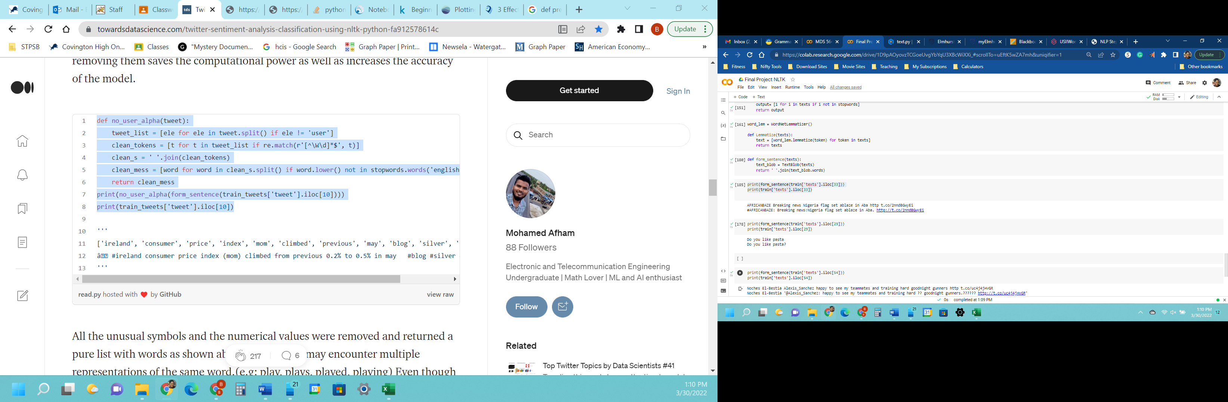

As with punctuations, stopwords played no significant part in the tweets. So, removing them would produce more accurate results and increase computer performance.

def no_user_alpha(text):

    ttext_list = [ele for ele in text.split() if ele != 'user']

    clean_tokens = [t for t in text_list if re.match(r'[^\W\d]*$', t)]

    clean_s = ' '.join(clean_tokens)

    clean_mess = [word for word in clean_s.split() if word.lower() not in stopwords.words('english')]

    return clean_mess

Another error was encountered. Stopwords had to be downloaded.

def remove_stopwords(texts):

    output= [i for i in texts if i not in stopwords]

    return output

Wordnet was downloaded.

nltk.download('wordnet')

WordNetLemmatizer was imported from NLTK so words could be converted to their bases.

import nltk

def normalization(texts_list):

        lem = WordNetLemmatizer()

        normalized_tweet = []

        for word in texts_list:

            normalized_text = lem.lemmatize(word,'v')

            normalized_tweet.append(normalized_text)

        return normalized_tweet

texts_list = 'I went shopping for goroceries. Then I went caroling. '.split()

print(normalization(texts_list))

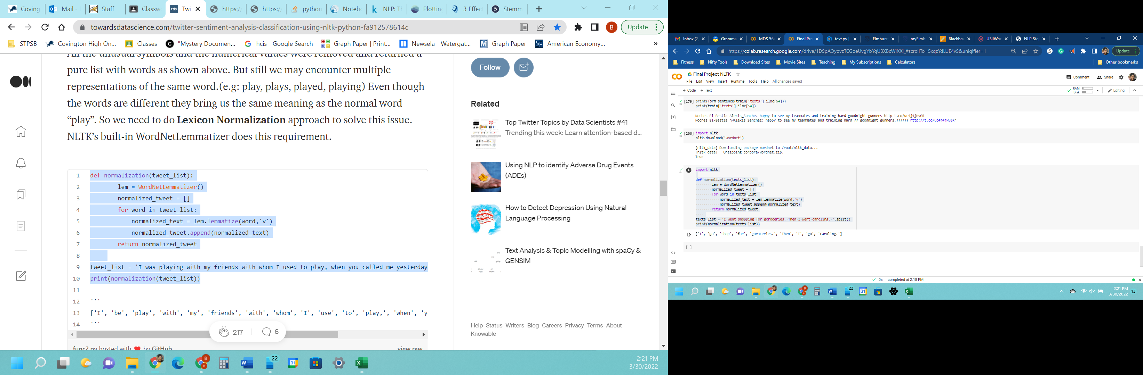

Progress was checked.

print(form_sentence(train['texts'].iloc[20]))

print(train['texts'].iloc[20])

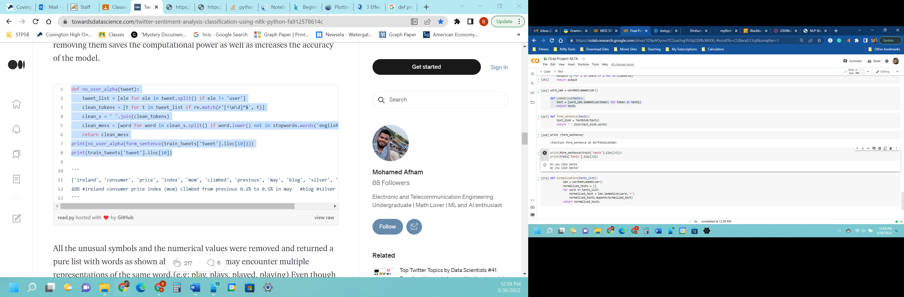

print(form_sentence(train['texts'].iloc[54]))

print(train['texts'].iloc[54])

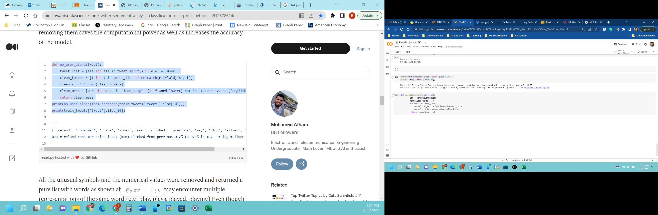

Normalization was performed to help decrease the number of unique words.

def normalization(texts_list):

        lem = WordNetLemmatizer()

        normalized_texts = []

        for word in texts_list:

            normalized_text = lem.lemmatize(word,'v')

            normalized_texts.append(normalized_text)

        return normalized_texts

The text was processed even more.

def text_process(mess):

  nopunc = [char for char in mess if char not in string.punctuation]

  nopunc = ''.join(nopunc)

  return [word for word in nopunc.split() if word.lower() not in stopwords.words('english')]

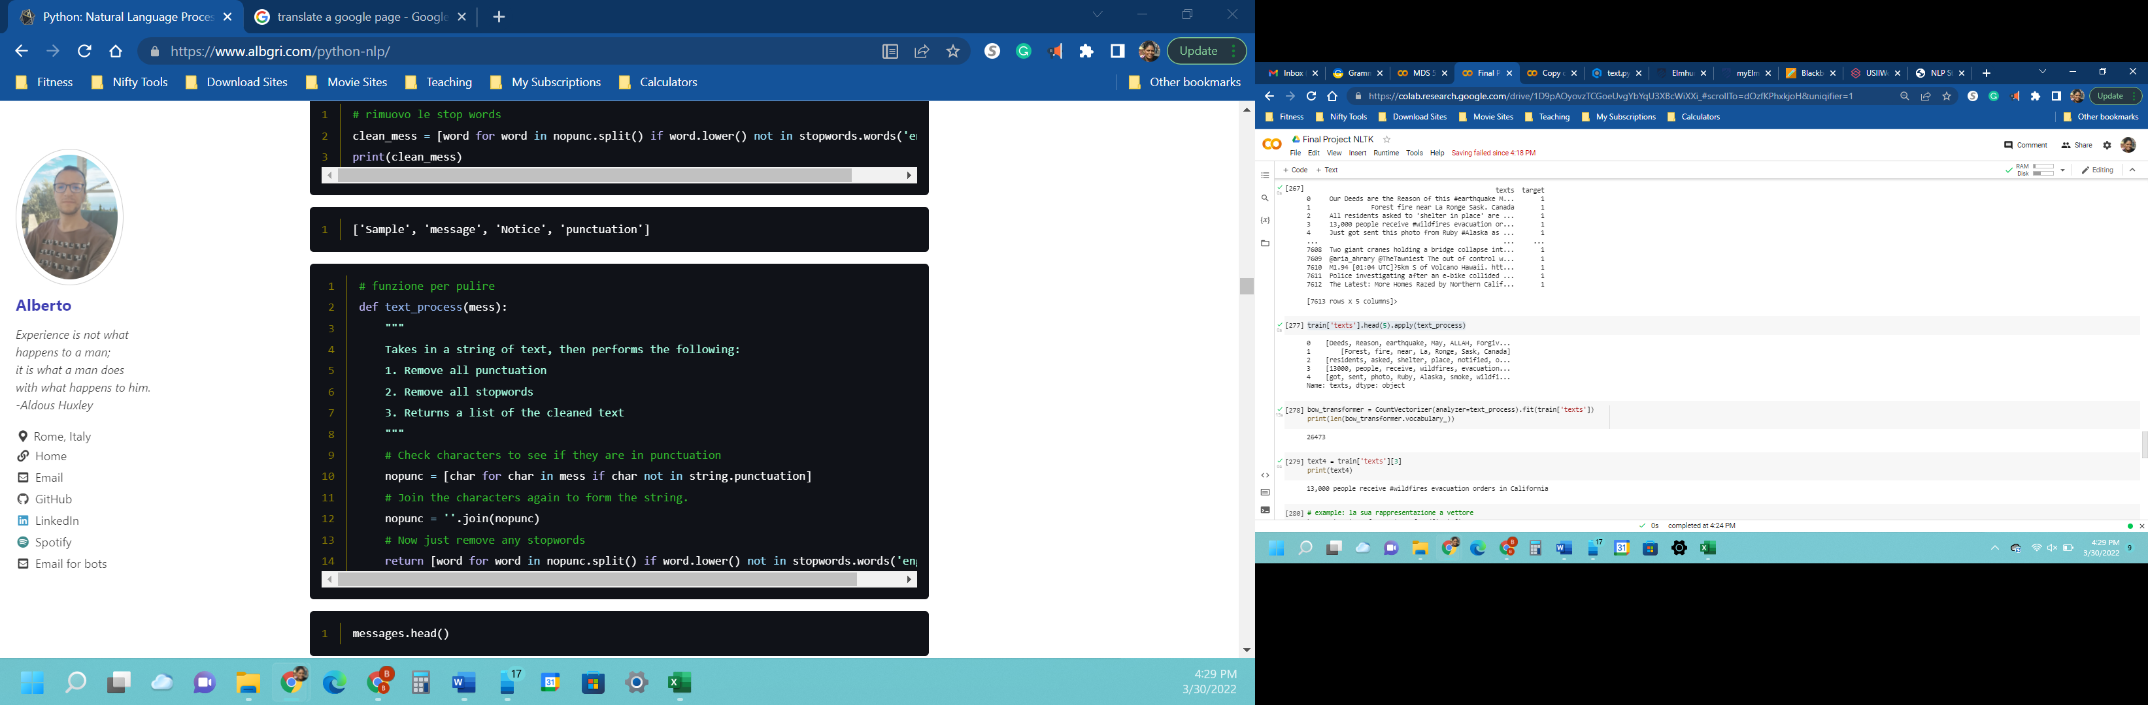

# II. VECTORIZATION

The tweets were converted into vectors with SciKitLearn. The process took three steps using the bag-of-words model.

1. Upon conducting a count, the number of tokens in the training tweets was calculated at 26,473.
2. The counts were weighed so that frequent token weight was less (IDF).
3. To find the length of the original text, the vectors were normalized to a single standard.

bow_transformer = CountVectorizer(analyzer=text_process).fit(train['texts'])

print(len(bow_transformer.vocabulary_))

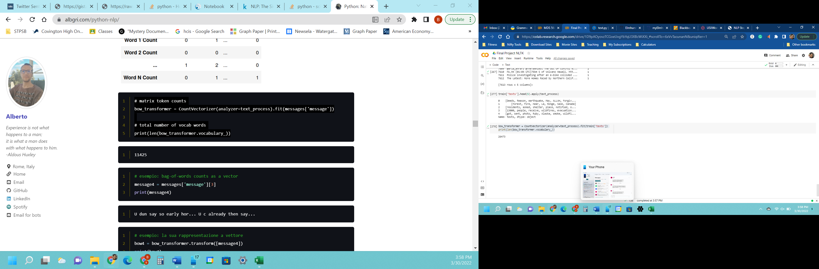

text4 = train['texts'][3]

print(text4)

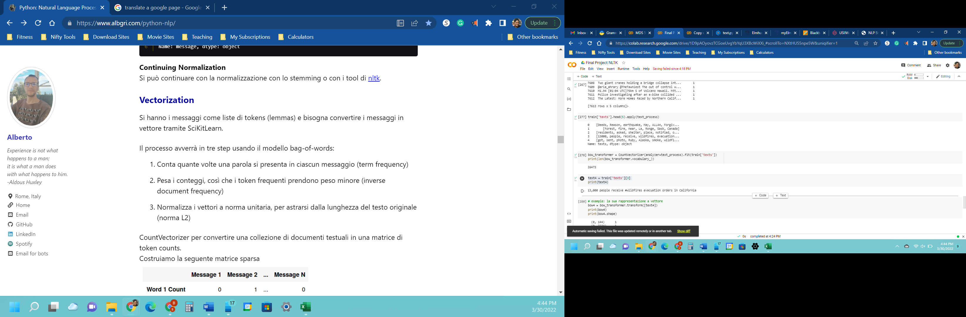

bow4 = bow_transformer.transform([text4])

print(bow4)

print(bow4.shape)

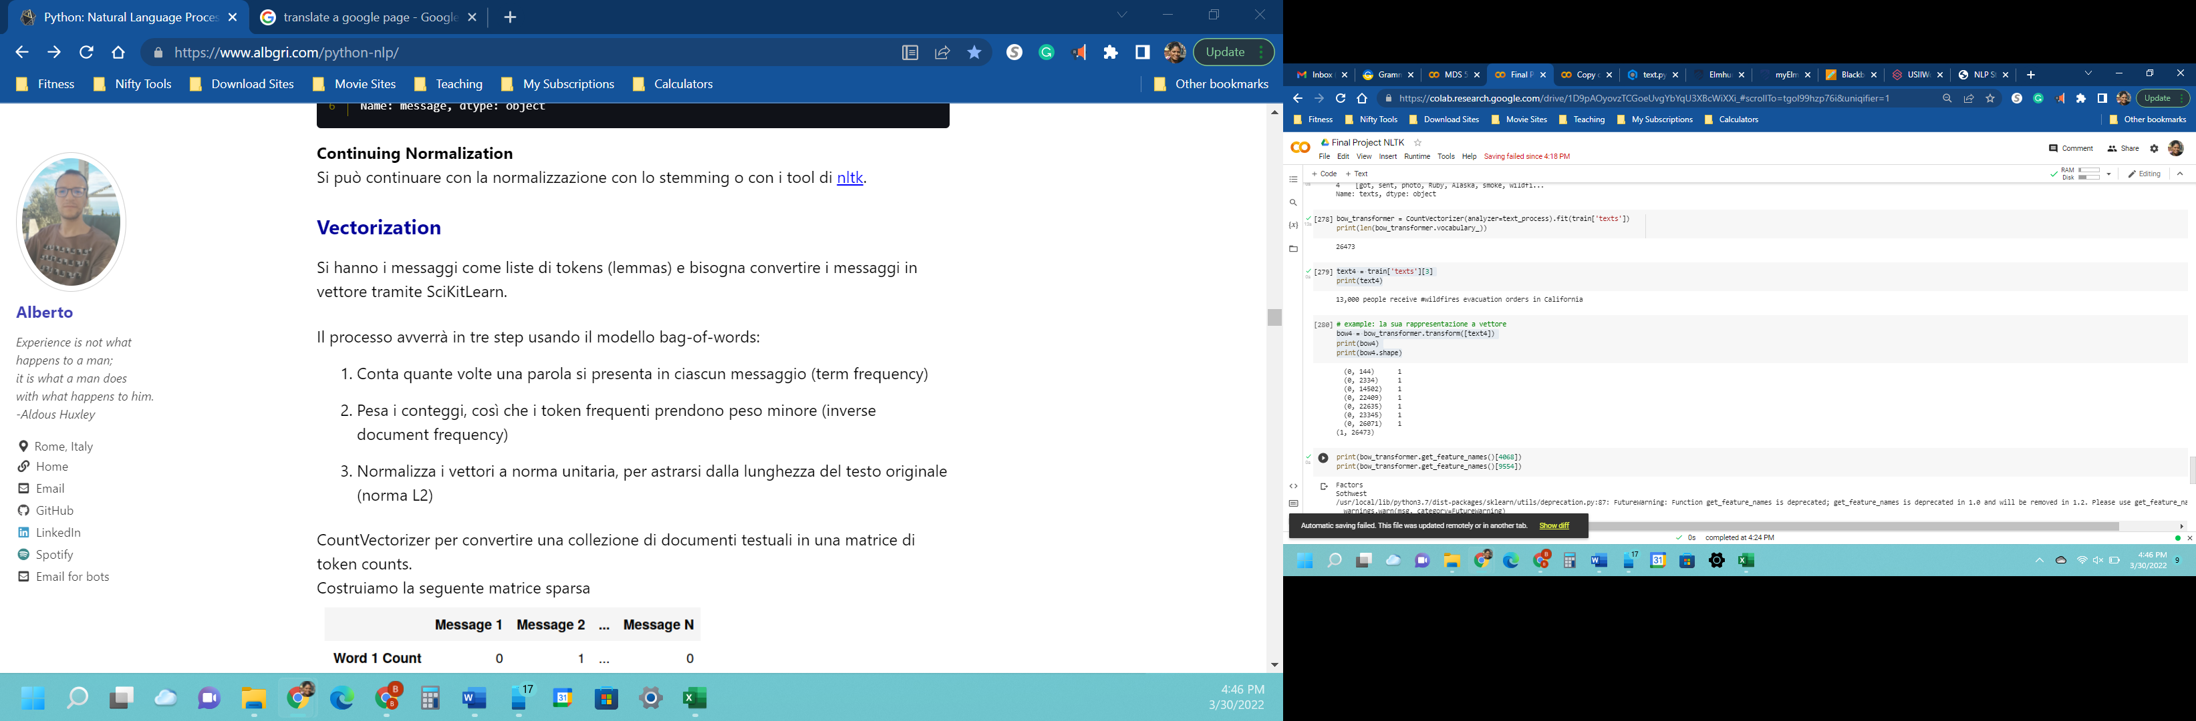

print(bow_transformer.get_feature_names()[4068])

print(bow_transformer.get_feature_names()[9554])

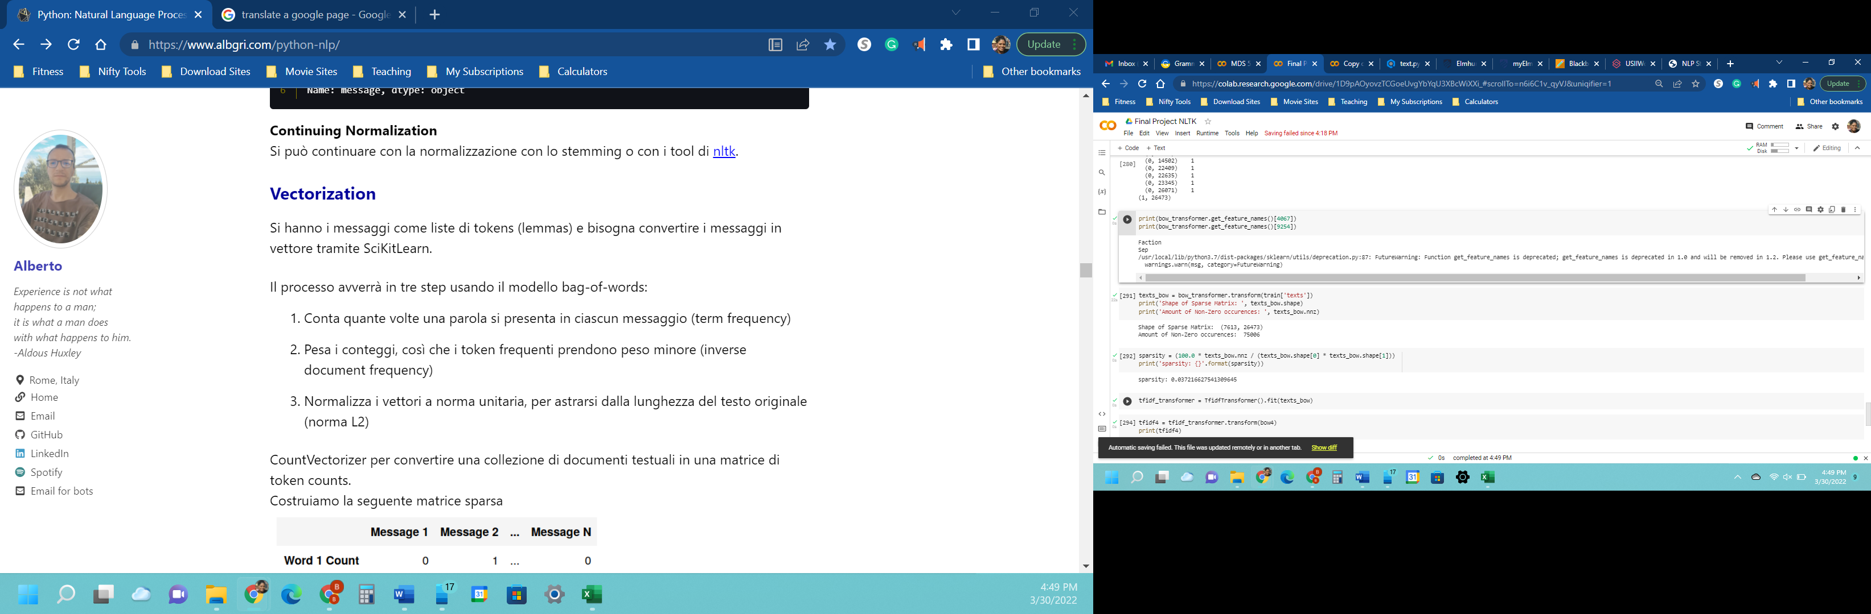

texts_bow = bow_transformer.transform(train['texts'])

print('Shape of Sparse Matrix: ', texts_bow.shape)

print('Amount of Non-Zero occurences: ', texts_bow.nnz)

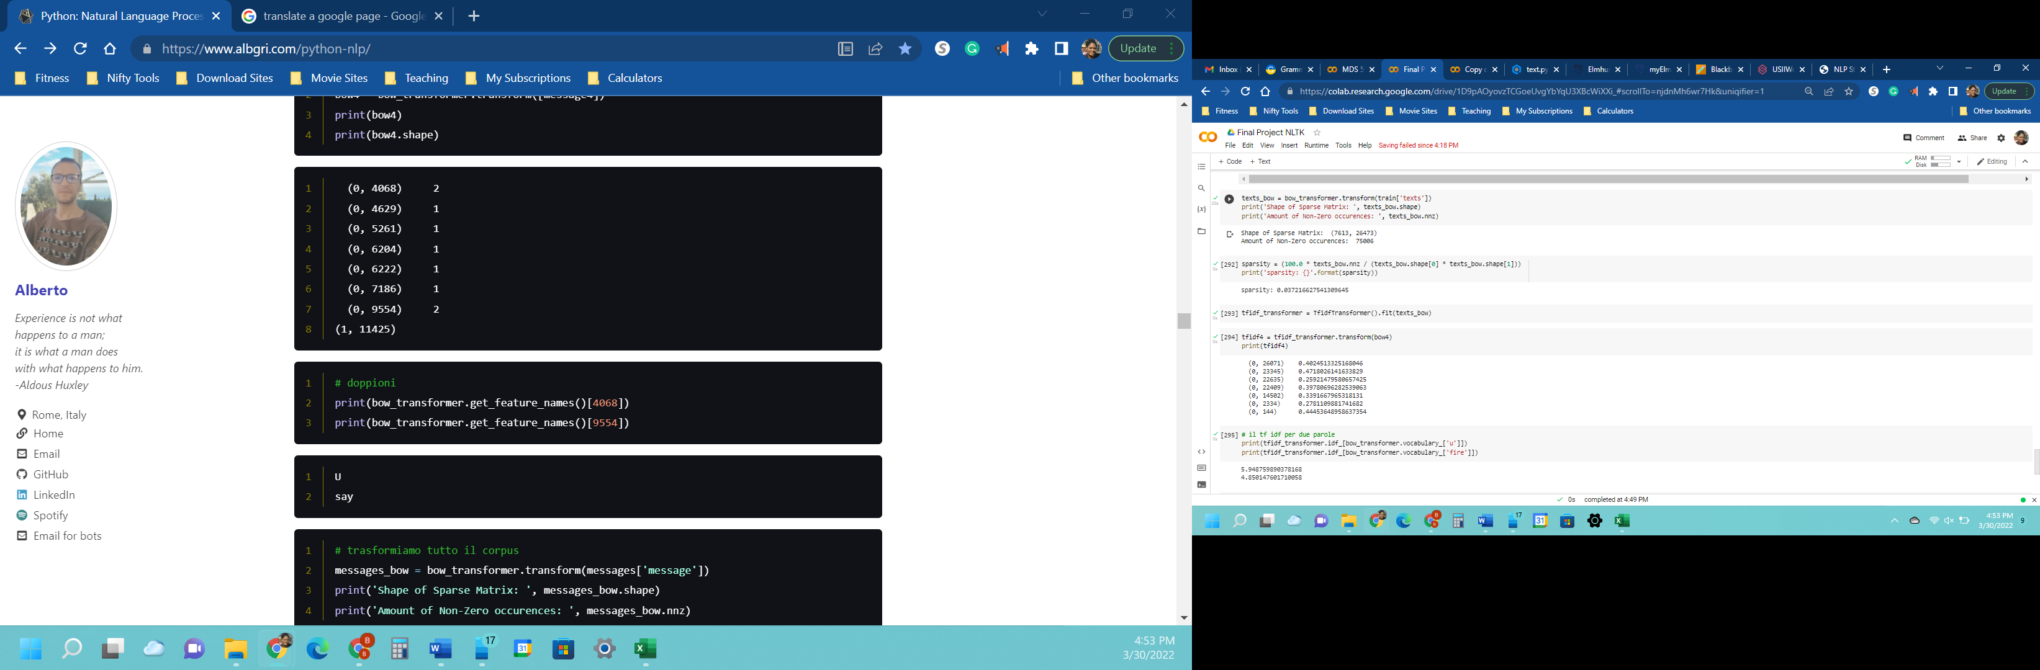

sparsity = (100.0 * texts_bow.nnz / (texts_bow.shape[0] * texts_bow.shape[1]))

print('sparsity: {}'.format(sparsity))

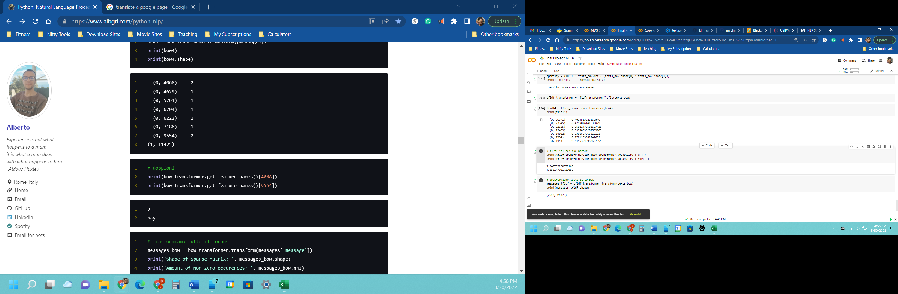

tfidf_transformer = TfidfTransformer().fit(texts_bow)

tfidf4 = tfidf_transformer.transform(bow4)

print(tfidf4)



print(tfidf_transformer.idf_[bow_transformer.vocabulary_['u']])

print(tfidf_transformer.idf_[bow_transformer.vocabulary_['fire']])

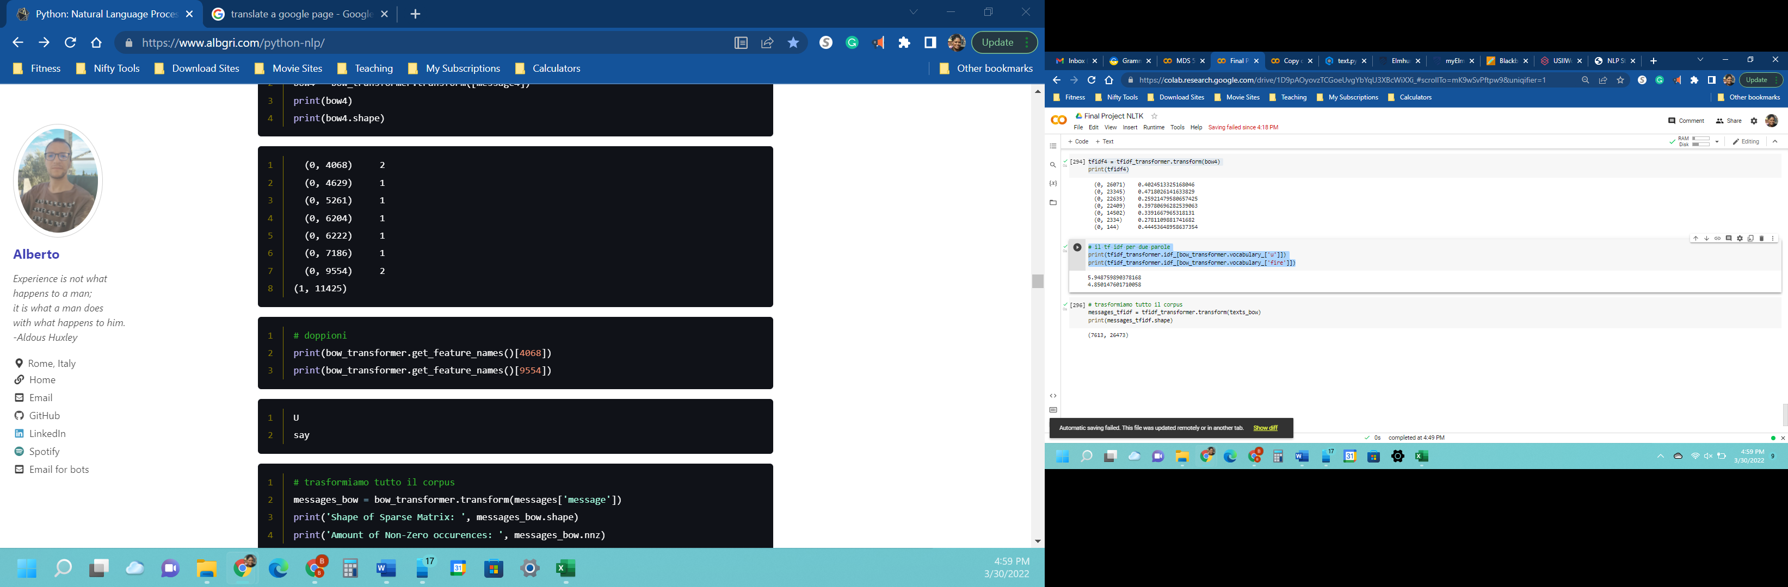

texts_tfidf = tfidf_transformer.transform(texts_bow)

print(texts_tfidf.shape)

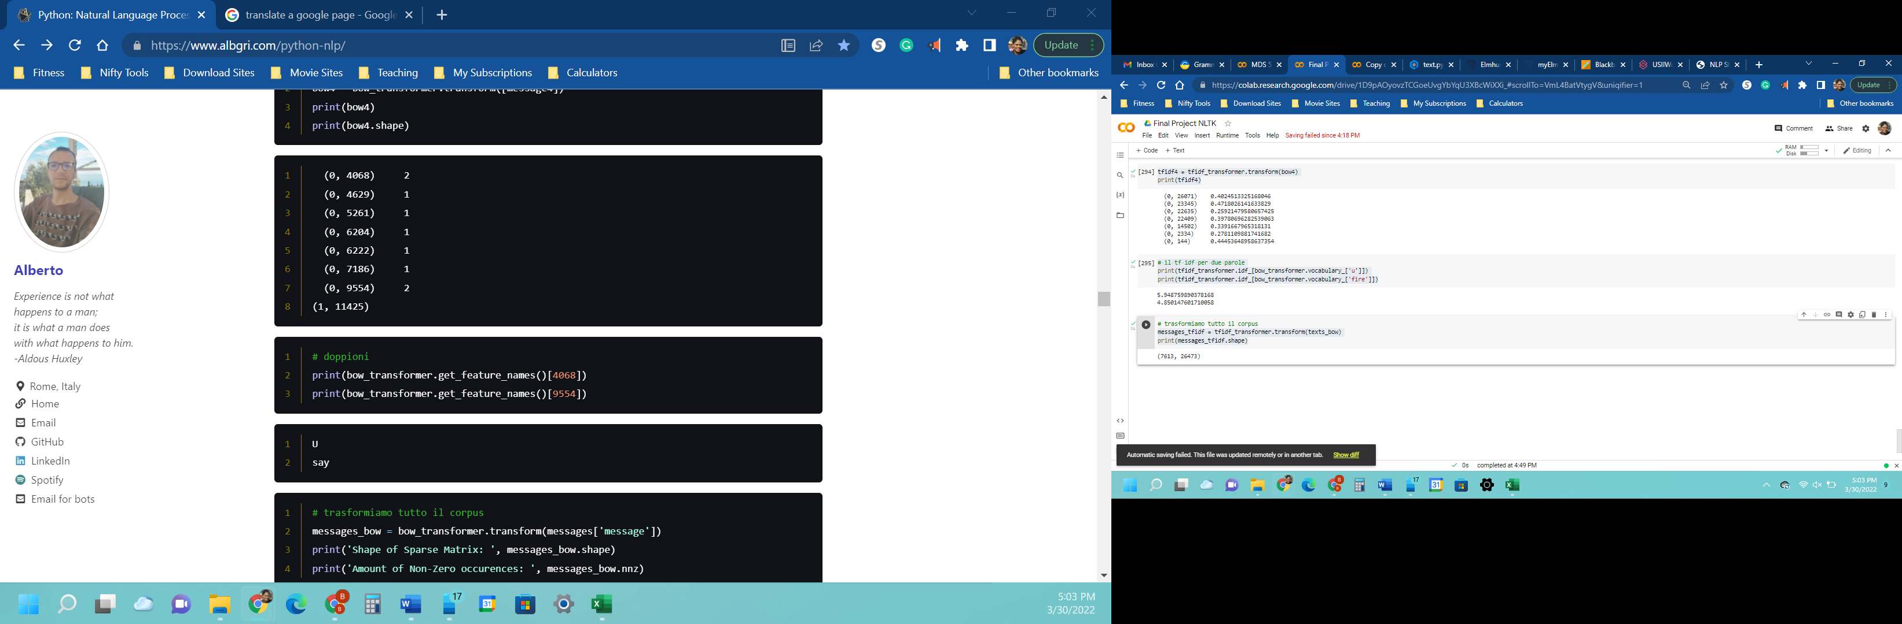

# III. MODELS AND RESULTS

The Naïve-Bayes Classifier was chosen because of the dataset’s small number of features. This algorithm will worked well for binary classification.

twitter_model = MultinomialNB().fit(texts_tfidf, train['target'])

print("Tweet:")

print(text4)

print("\nVectorized Form")

print(bow4)

print("\nTF-IDF")

print(tfidf4)

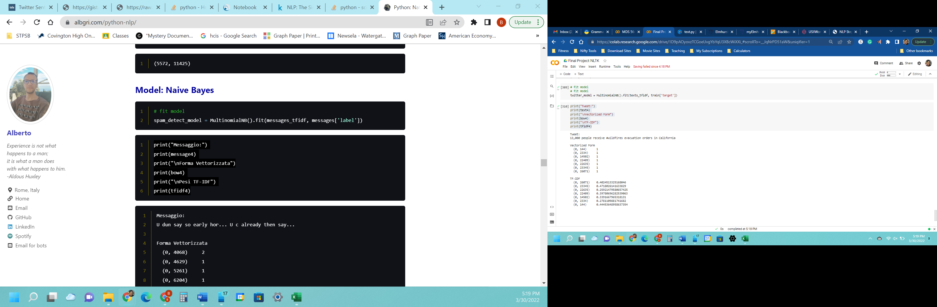

print('predicted:', twitter_model.predict(tfidf4)[0])

print('expected:', train.target[3])

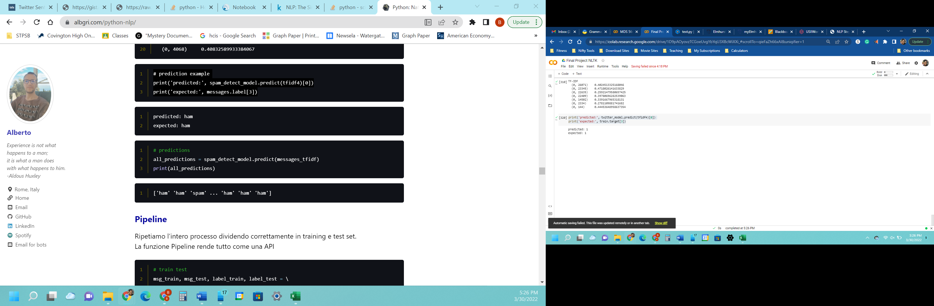

all_predictions = twitter_model.predict(texts_tfidf)

print(all_predictions)

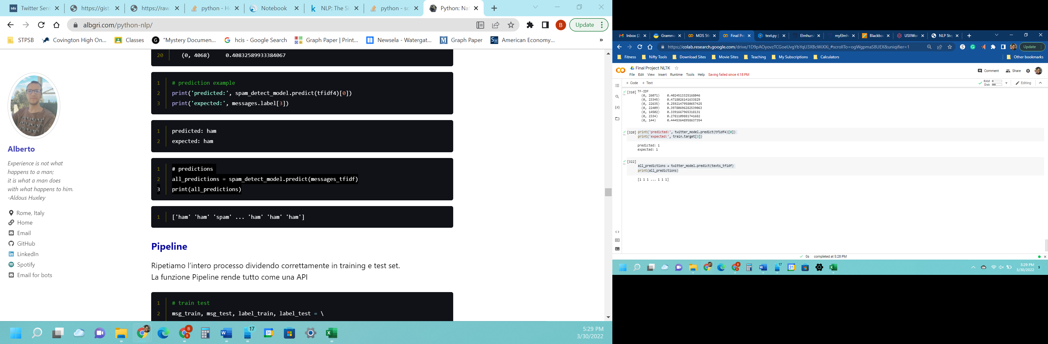

# IV. PIPELINE

Here the steps were repeated by correctly dividing the data into training and test datasets. The pipeline function works similarly to an API.

msg_train, msg_test, label_train, target_test = \

train_test_split(train['texts'], train['target'], test_size=0.2)

print(len(msg_train), len(msg_test), len(msg_train) + len(msg_test))

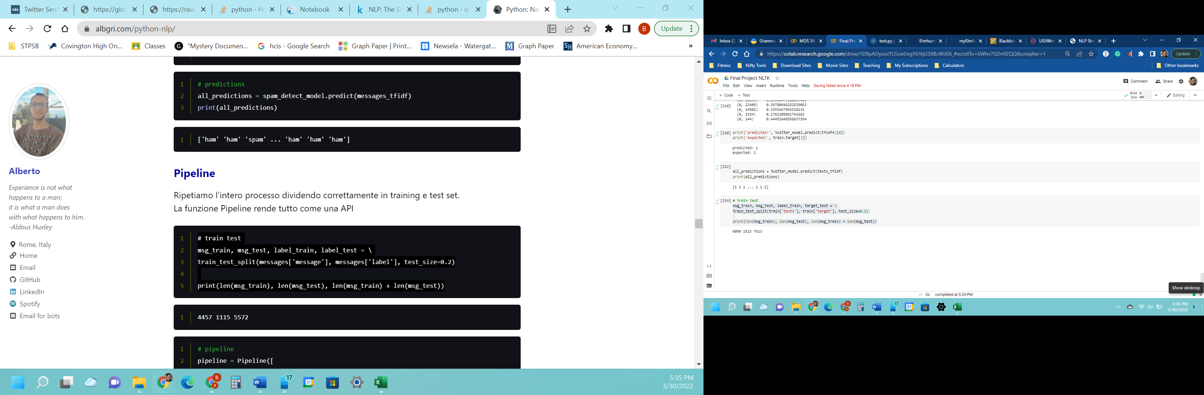

pipeline = Pipeline([

    ('bow', CountVectorizer(analyzer=text_process)),

    ('tfidf', TfidfTransformer()),

    ('classifier', MultinomialNB()),

])

pipeline.fit(msg_train,label_train)

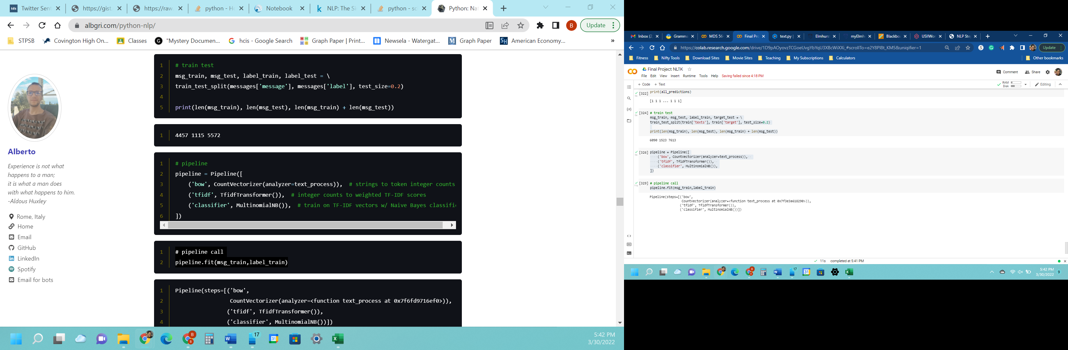

predictions = pipeline.predict(msg_test)

print(classification_report(predictions,target_test))

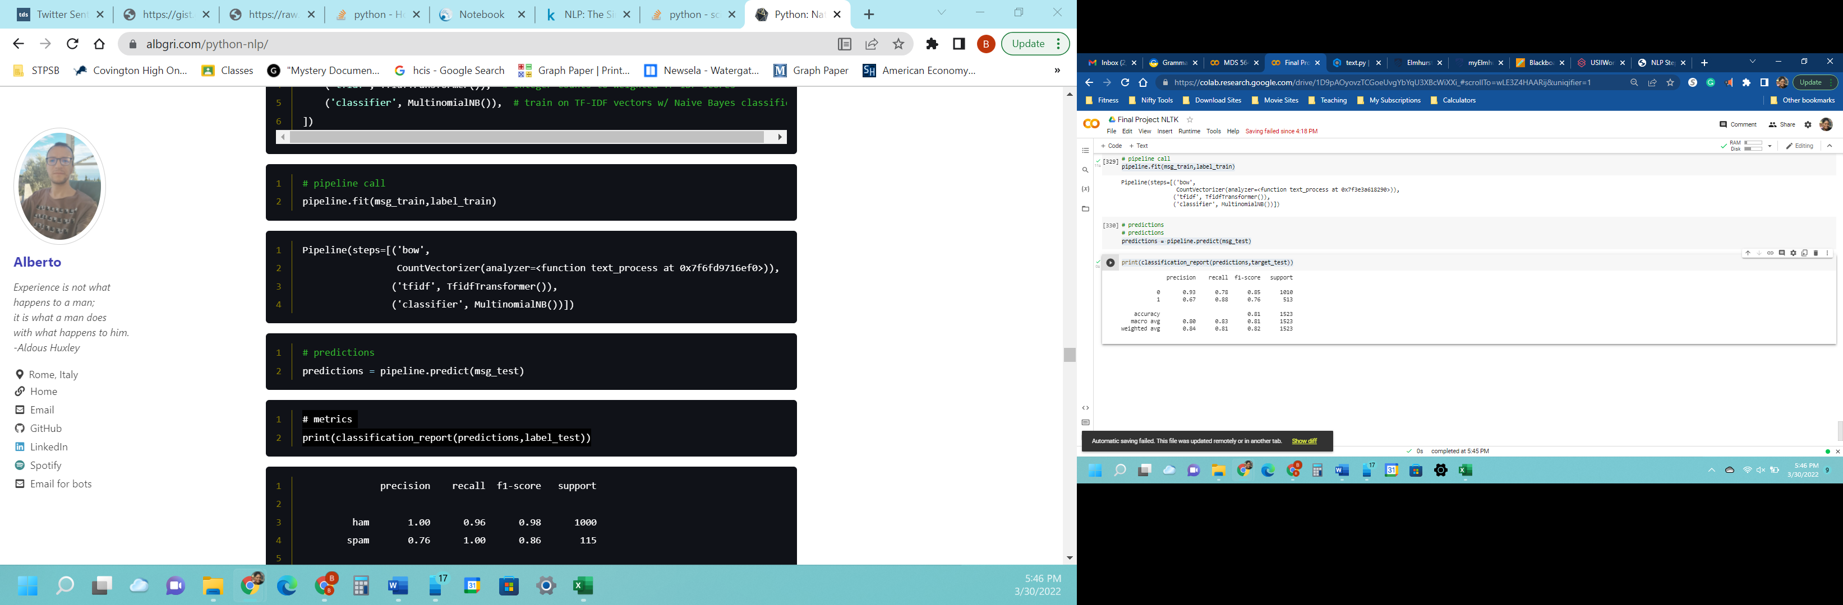

From the calculation of support, the dataset was determined to be unbalanced. The model found that 0.98 of non-disaster tweets and 0.67 of disaster tweets were correctly classified. The mean of precision and recall for the non-disaster tweets is 0.85 and 0.76 for disaster tweets. An accuracy of 0.81 was obtained using the simple pipeline model.

# V. CONCLUSION

For this study, the Naïve-Bayes Classifier worked well at differentiating between non-disaster and disaster tweets. Using this algorithm proved to be a long, tedious task. While there are methods, like BERT and GPT-2/ 3, that are better at understanding human language, this approach is not a black box that requires a lot of computational resources. This method allows for a better understanding of NLP.

**REFERENCES**

*Natural language processing with disaster tweets.* Kaggle. (n.d.). Retrieved February 22, 2022, from https://www.kaggle.com/c/nlp-getting-started

*Social Media Stats Worldwide*. StatCounter Global Stats. (n.d.). Retrieved March 6, 2022, from https://gs.statcounter.com/social-media-stats

*Number of users worldwide from 2019 to 2024*. Statista. (2022, January 28). Retrieved March 11, 2022, from https://www.statista.com/statistics/303681/twitter-users-worldwide/